<Insert Project Name>
<Author Here>
Created/updated 15/02/23

Highlight Report
Phase 3 Template

Highlight Report
Project Name:
Date: |  | Release: | Draft/Final
Author:
Owner:
Client:
Document number:
Note: This document is only valid on the day it was printed

Revision history
Date of next revision:
Revision date | Previous revision date | Summary of changes | Changes marked

Approvals
This document requires the following approvals. A signed copy should be placed in the project files.
Name | Signature | Title | Date of issue | Version

Distribution
This document has been distributed to:
Name | Title | Date of issue | Version

Overview

Purpose | A Highlight Report is used to provide the Project Board (and possibly other stakeholders) with a summary of the stage status at intervals defined by them. The Project Board uses the report to monitor stage and project progress. The Project Manager also uses it to advise the Project Board of any potential problems or areas where the Project Board could help.
Contents | The Highlight Report should cover the following topics.  Status Summary 4  This Reporting Period 4  Next Reporting Period 5  Project and Stage Tolerance Status 6  Requests for Change 6  Key Issues and Risks 6  Lessons Report (if appropriate) 6
Advice | The Highlight Report is derived from the: Project Initiation Documentation; Checkpoint Reports; Issue Register, Quality Register and Risk Register; Stage Plan and actuals: and Communication Management Strategy  The Highlight Report can take a number of formats, including: Presentation to the Project Board (physical meeting or conference call); Document or email to the Project Board; Entry in a project management tool.  The following quality criteria should be observed:  - The level and frequency of progress reporting required by the Project Board is right for the stage and/or project  - The Project Manager provides the Highlight Report at the frequency, and with the content, required by the Project Board  - The information is timely, useful, accurate and objective  - The report highlights any potential problem areas

Date of checkpoint
Period covered

Status Summary
(An overview of the status of the stage at this time)

This reporting period

Work packages
Work package ref | Work package name | Status | Notes

Products
Product ref | Product name | Status | Notes

Corrective actions undertaken
(Taken during the period)

Next reporting period

Work packages
Work package ref | Work package name | Status | Notes

Products to me completed
Product Ref |  | Product name |  | Notes

Corrective actions
(To be completed during the next period))

Project and stage tolerance status
(How execution of the project and stage are performing against its tolerances (e.g. cost/time/scope actuals and forecast))

Requests for change
(Identifying any raised, approved/rejected and pending)

Key issues and risks
(Summary of actual or potential problems and risks)

Lessons report (if appropriate)
(A review of what went well, what went badly, and any recommendations for corporate or programme management consideration)

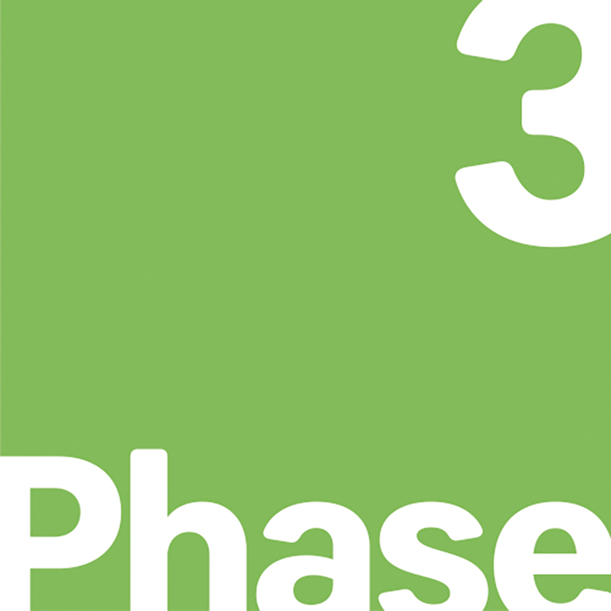
info@phase3.co.uk www.phase3.co.uk 0800 321 3032
Swan Square, 56 Oak Street, Manchester, M4 5JA Company number: 05034692
This document is the property of Phase 3 Consulting Limited
© Copyright 2022 Phase3 Limited | All rights reserved
Classification – Public

Either Pending Authorisation, In Execution or Completed (in the period)
For example if Work Packages are being performed by external suppliers, this information may be accompanied by purchase order and invoicing data
Completed (in the period), Planned (but not started or completed) or Underway (as planned)
Indicate if any products are running behind schedule.
Either To be authorized, In-execution, and To be completed during the next period
For example if Work Packages are being performed by external suppliers, this information may be accompanied by purchase order and invoicing data

